**HTML ASSIGNMENT**

1. **Write HTML for the following screen.**

<body bgcolor="yellow";>  
<h1 style="background-color:red;">This is Heading tag</h1>  
<p style="background-color:green;">This is paragraph tag</p>

**2.Write the HTML for following , first image has border while another image don’t have any border**

<body>  
<p>Here we have a emoji with a link and border.  
 <a href="www.emoticons.com">  
 <img src="1.jpg" alt="picture of an emoji" height="40px", width="40px" style="border:3px solid black;">  
 </a>  
 <p>there is no border</p>  
 <a href="www.emoticons.com">  
 <img src="1.jpg" alt="picture of an emoji" height="40px", width="40px">  
 </a>

1. 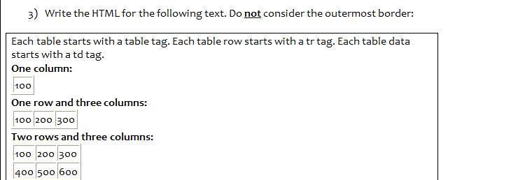
2. <table width="120px">  
    <tr>One column  
    <td>100</td>  
    </tr>  
   </table>  
   <table>  
    <tr>  
    One column three row  
    <td>100</td>  
    <td>200</td>  
    <td>300</td>  
    </tr>  
   </table>  
   <table>  
    <tr>  
    Two row three column  
    <td>100</td>  
    <td>200</td>  
    <td>300</td>  
    </tr>  
    <tr>  
    <td>400</td>  
    <td>500</td>  
    <td>600</td>  
    </tr>  
   </table>

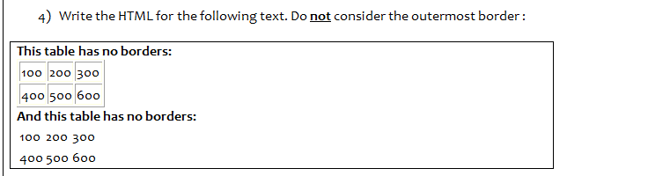

<table border="1">  
 <tr>  
 these have borders  
 <td>100</td>  
 <td>200</td>  
 <td>300</td>  
 </tr>  
 <tr>  
 <td>400</td>  
 <td>500</td>  
 <td>600</td>  
 </tr>  
</table>  
<table>  
 <tr>  
 these do not have borders  
 <td>100</td>  
 <td>200</td>  
 <td>300</td>  
 </tr>  
 <tr>  
 <td>400</td>  
 <td>500</td>  
 <td>600</td>  
 </tr>  
</table>

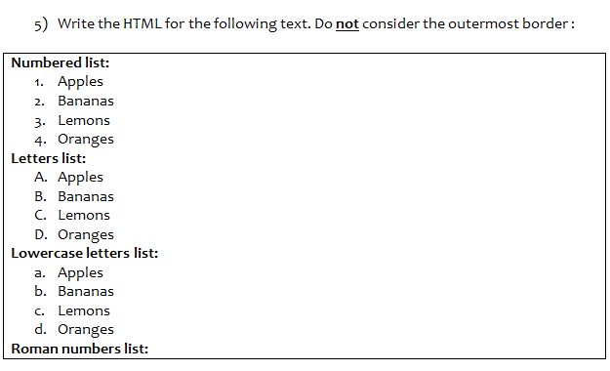

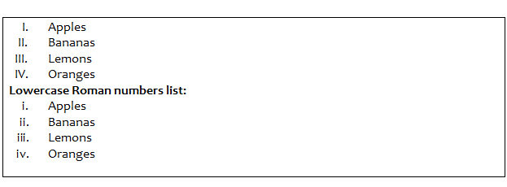

<body>  
<h1>Number list</h1>  
<ol type = "1">  
 <li>Apples</li>  
 <li>Bananas</li>  
 <li>Lemons</li>  
 <li>Oranges</li>  
</ol>  
<h1>Letters list</h1>  
 <ol type="A">  
 <li>Apples</li>  
 <li>Bananas</li>  
 <li>Lemons</li>  
 <li>Oranges</li>  
 </ol>  
<h1>lower case letters list</h1>  
 <ol type="a">  
 <li>Apples</li>  
 <li>Bananas</li>  
 <li>Lemons</li>  
 <li>Oranges</li>  
 </ol>  
<h1>Roman Number</h1>  
 <ol type="I">  
 <li>Apples</li>  
 <li>Bananas</li>  
 <li>Lemons</li>  
 <li>Oranges</li>  
 </ol>  
<h1>lower Romans number</h1>  
 <ol type="i">  
 <li>Apples</li>  
 <li>Bananas</li>  
 <li>Lemons</li>  
 <li>Oranges</li>  
 </ol>  
</body>

# 6. Create a user name and password field. password must be in masked form

<h1>Create a user name and password field. password must be in masked form</h1>  
<form action="">  
 <label for="username">Username</label>  
 <input type="text" name="username">  
 <br><br>  
 <label for="password">Password</label>  
 <input type="password" name="password">  
</form>

7. Make two checkbox with submit button

<form action="">  
 <input type="checkbox" name="bike"> I have a bike  
 <br>  
 <input type="checkbox" name="car">I have a car  
 <br>  
 <input type="submit" value="submit" name="submit">  
</form>

8

<table width="50%">  
 <tr>  
 <td colspan="2" bgcolor="skyblue">top</td>  
 </tr>  
 <tr>  
 <td bgcolor="grey">left</td>  
 <td bgcolor="#988">Right</td>  
 </tr>  
</table>

9.

<table width="50%">  
 <tr>  
 <td bgcolor="grey">topleft</td>  
 <td bgcolor="silver">topright</td>  
 </tr>  
 <tr>  
 <td rowspan="2" bgcolor="silver">Botleft</td>  
 <td rowspan="2" bgcolor="grey">BotRight</td>  
 </tr>  
</table>

.